State
Commercial Baking and Pastry Arts
Contest

April 13th, 2024

This contest will be faciliated at Carroll County Career and Technology Center

Schedule (subject to change)
8:00 a.m.- 8:30 Orientation
8:30 - 11:30 Competition Performance
11:30 - 12:00 Lunch
12:00 - 1:30 Competition Performance
1:30 – 2:00 Student Clean-Up
2:00 p.m. Contest Concludes

No students will leave the competition area until kitchen is completely clean, including sweeping and mopping.

Resume

Contestants will provide a current resume for review. Hand all resumes to the competition chair during the contestant orientation.

Performance Test

Contestants will demonstrate proper baking skills with emphasis on good planning, accurate measurements, the proper use and handling of ingredients, appropriate use of equipment, and an ability to use standard formulas. During production, judges will be looking for safe and sanitary work habits, as well as the efficient use of materials (minimal waste.) In the finished product judges will be looking for consistency, uniformity, and a finished product that can be sold to the consumer.

During competition it is your responsibility as a competitor to keep track of your products. Keep your products together in your designated areas. It is mandatory that you present your products as you finish them to minimize time for products getting misplaced or lost. There will be no considerations for lost, misplaced or swapped items in any circumstance.

During the competition, it is also your responsibility to keep up with your dishes as you work, and to clean your station and all common areas at the end of the day. Your goal is the leave the kitchen better than you found it. Cleaning as you go is key to reducing the amount of cleaning required at the end of the day. No student will leave the competition area until the kitchen is completely cleaned, including all common areas, the floors, the dish areas, and the stove tops, as well as your own stations. All equipment provided by the competition must be returned to the speed rack or area you found it in. Any additional equipment you are given must be returned to the competition chair directly.

Display of Final Products

Final products are to be displayed on clean two sheet plans with pan liners. Your competitor number must be on both sheet pans. Any leftover doughs are also to be placed on numbered presentation sheet pans.

Final Products (display all products)

- Pate a Choux
  - 12 Eclairs
  - 12 Paris-Brest
  - Display Eclairs: 2 filled and 10 unfilled. No garnish required
  - Display Paris-Brest: 2 filled and 10 unfilled. No garnish required

- Crème Patisserie
  - Show an evaluator as soon as it comes off the stove.
  - Save remainder for later use

- Chocolate Chip Cookies
  - Prepare and Display 12 cookies, 58 g (2 oz)
  - Prepare and Display 45 cookies, 28 g (1 oz)

- Savory Galette
  - Prepare Galette Filling (peppers, onions, garlic, and Zucchini)
    - Display a small amount of Galette filling
  - Prepare and Display four (4) Savory Galettes
  - Display 2 oz. (60 g) of combined knife cuts
  - Display 6 muffins

- Decorated Cake
  - Prepare and Display 1, 8” cake based on provided work order.

Technical Standards for Commercial Baking Clothing Requirement

Clean and pressed white or checkered work pants, white chef’s coat or baker’s shirt, black or white non-slip work shoes (closed leather upper), white apron, and hat.
Students will be disqualified for improper shoes in accordance with OSHA safety standards. Hairnets are not required if all hair is tucked completely into hats.

Equipment and Materials Supplied by Contestant

- Off-set spatula
- Rubber spatula, high heat silicone
- Hand whisk
- Large kitchen spoon
- 2 Pastry bags
- 2 Pastry tips (rose tip and either star or round tips for boarders)
- Scissors
- Bowl scraper
- Flower nail
- Disposable gloves
- Cake comb
- Thermometer
- Timer
- Measuring Cups and Spoons
- Pencil
- Marker
- Serrated paring knife for pate a choux
- Serrated cake knife for cake
- Chef knife for vegetable knife cuts

Provided by the Site

- Turntables
- Nested Bowls
- Mixer and Attachments
- 1 Pot
- 1 Sauté Pan
- Liquid Measuring Cups
- Decorating Colors
- Oven Mitts/Pads
- Side Towels (2)
- Scale, digital
- 2 ea. 8” cake layers
- Cake boards (8” base board, 10” finish board)
- Doily (10”)
- Cake turntables
- Masking tape
- Muffin cups, paper
- Parchment paper
- 3 full Sheet pans
- 3 half Sheet pans
- Muffin pans
- Portion scoop (blue)
- Quarter sheet pan (to hold pastry cream)
- Ramekin (to display pastry cream)
- Small plate (to display knife cuts)

NO FOOD SUBSTANCES OF ANY KIND WILL BE PERMITTED.
YOU WILL HAVE 10 POINTS DEDUCTED FOR EACH FOOD ITEM IN TOOL KIT.

List of Equipment and Materials Supplied by Contestant are recommended but not required. Students may bring additional small tools with discretion by the judges. There will be no tools available to borrow.

Pate a Choux

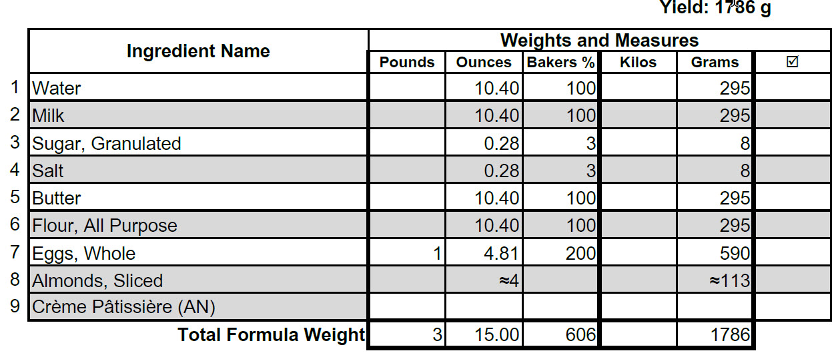

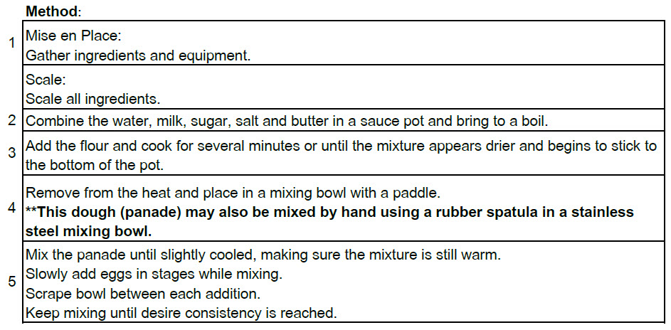

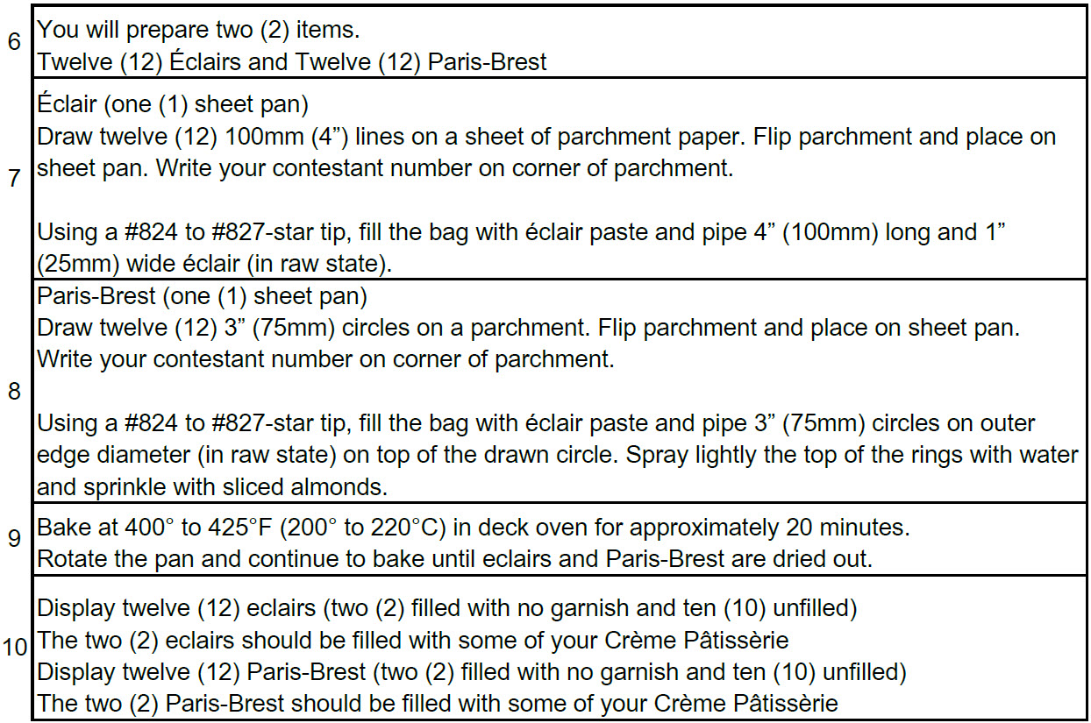
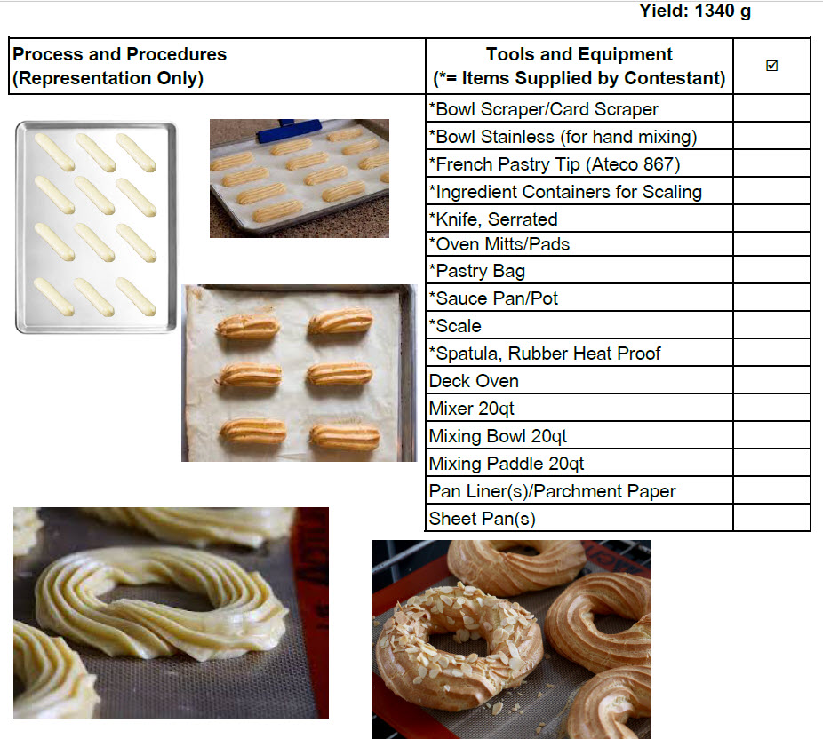

Crème Patisserie

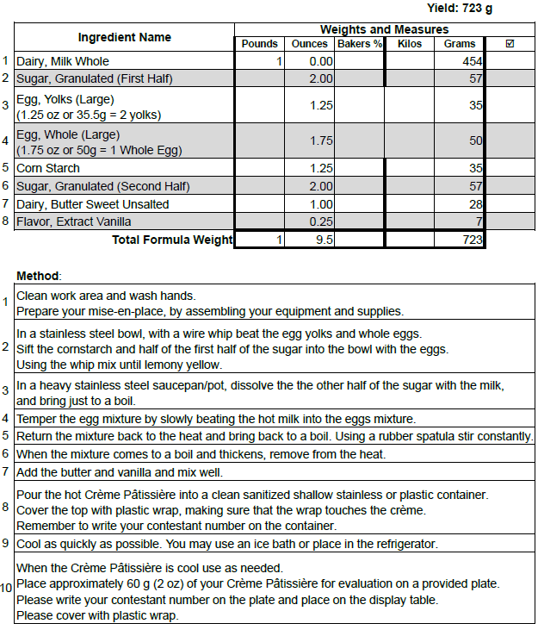

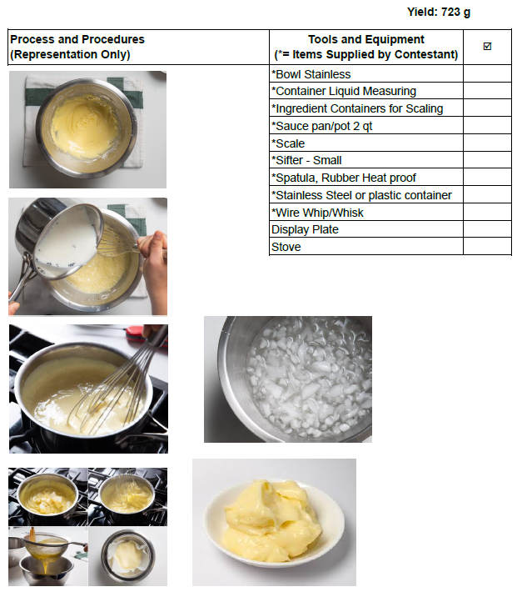
Cranberry Oatmeal Cookie

Yield: 35 cookies at 57g (2 oz.) each
70 cookies at 28g (1 oz.) each
2105 g total
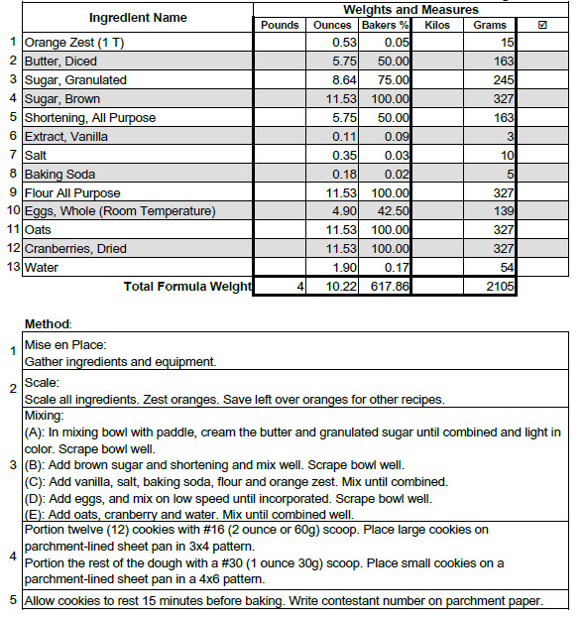

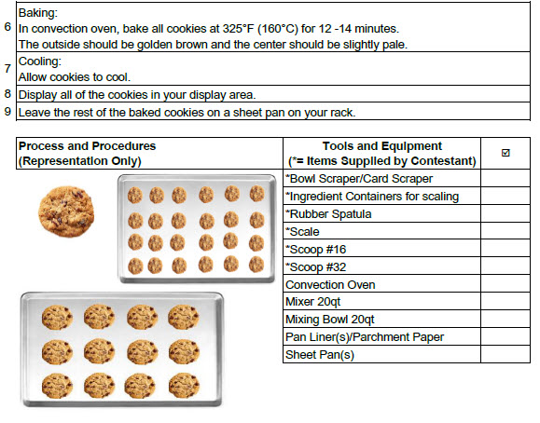

Savory Galette

Savory Galette Filling
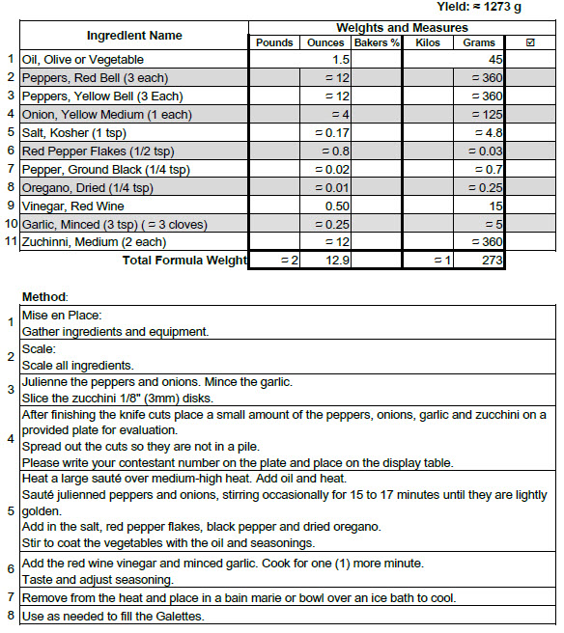

Savory Galette
Note: Galette dough will be 2, pre-made puff pastry sheets (1/2 sheet per galette).
Use option A in the directions

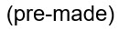
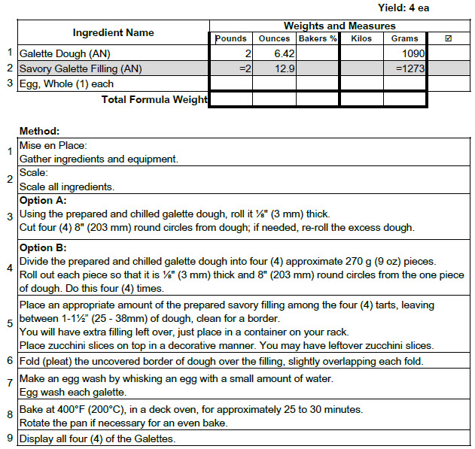

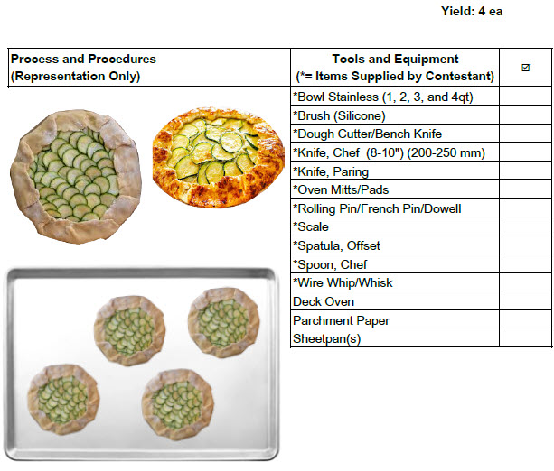

Decorated 8” Cake

