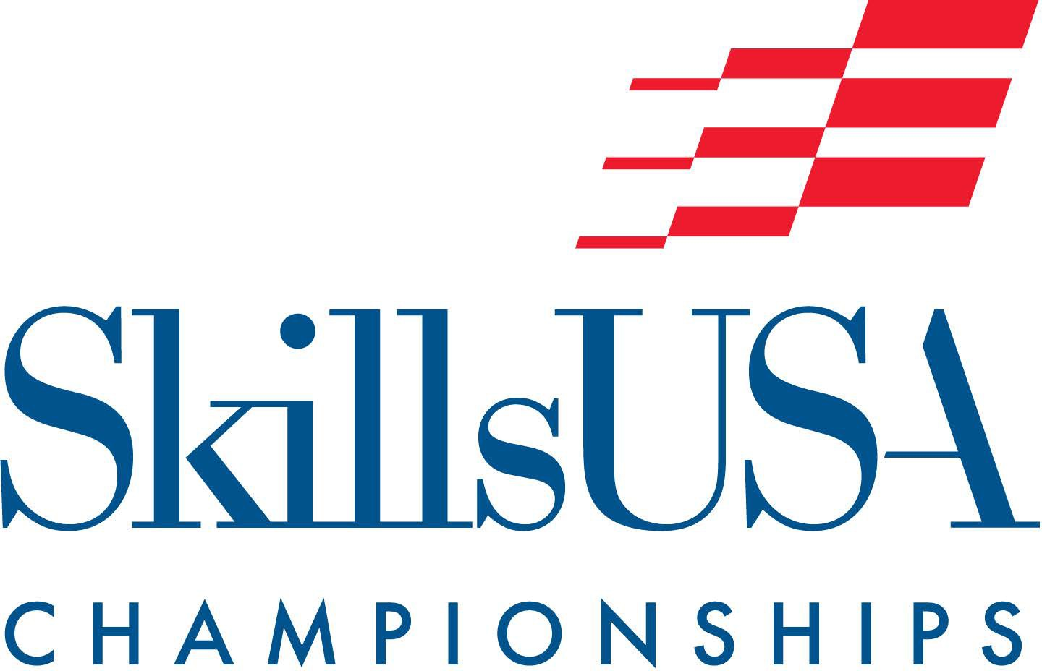
SKILLSUSA MARYLAND
2027 STATE CHAMPIONSHIP COMPETITIONS
(With Official Codes/Number Competitors Allowed - Contests That Do Not
Require Regional Competitions aka "Straight to States" in Blue

Revised 7/23/26

3D Visualization and Animation VA-2

Action Skills (includes MS) AS-1 (register up to 5 students per chapter)
Additive Manufacturing ( includes MS) AMF -2
Advertising Design ADV-1

American Spirit (includes MS) AM-3 (register 1 team per chapter)
Architectural Drafting AD-1
Audio/Radio Production RAP-2
Automated Manufacturing Technology MFG-3 Automotive Maintenance and Light Repair MLR-1 Automotive Refinishing Technology ART-1 Automotive Service Technology AST-1
Aviation Maintenance Technology AMT-1
Baking and Pastry Arts CB-1
Barbering BAR-1
Basic Health Care Skills CARE-1 Building Maintenance BLMT-1 Cabinetmaking CM-1

Career & Technical Educator Demo CTE-1 (register 1 student per chapter)
Career Pathways Showcase:
Arts and Communications Cluster: CPSA-3
>Arts, Audiovisual Technology and Communications
Business, Management and Technology Cluster: CPSB-3
>Business Management and Administration
>Finance Services
>Information Technology
>Marketing, Sales and Services
Health Services Cluster: CPSC-3
>Health Science
Human Services Cluster: CPSD-3
>Government and Public Administration
>Law, Public Safety and Security
>Education and Training Services
>Human Services
>Hospitality and Tourism
Industrial and Engineering Technology Cluster: CPSE-3
>Architecture and Construction
>Manufacturing
>Science, Technology and Math
>Transportation Distribution and Logistics
Natural Resources/Agriculture/Food Cluster: CPSF-3
>Agricultural, Food and Natural Resources Carpentry C-1

Chapter Business Procedure CBP-6 (register 1 team per chapter)
Chapter Display (includes MS) DIS-3 (register 1 team per chapter)
CNC 2-Axis Turning Programmer CNCT-1 CNC 3-Axis Milling Programmer CNCM-1 CNC 5-Axis Milling Programmer CNCX-1 CNC Programmer PMT-1
Collision Damage Appraisal CDA-1 Collision Repair Technology CRT-1 Commercial sUAS Drone DT- 2
Community Action Project (includes MS) CAP-2 (register 1 team per chapter)

Community Service (includes MS) CS-3 (register up to 2 teams per chapter)
Computer Programming CP-1
Cosmetology CO-1
Crime Scene Investigation CSI-3
Criminal Justice CJ-1
Culinary Arts CA-1

Customer Service CUS-1 (register up to 3 students per chapter)
Cyber Security -CY- 2
Dental Assisting DA-1
Diesel Equipment Technology DET-1 Digital Cinema Production VPD-2 Early Childhood Education PRE-1 Electrical Construction Wiring ECW-1
Electronics Technology Design (includes MS) ET-1
Emergency Medical Technician MMT-2

Employment Application Process EAP-1 (register up to 3 students per chapter)
Engineering Technology-Design ENG-3
Entrepreneurship ENTR-4
Esthetics EST-1

Extemporaneous Speaking (includes MS) ES-1 (register up to 4 per chapter)
Facilithon – Leadership in Facility Management FM-1
Firefighting FF-1
First Aid/CPR CPR-1
Graphic Communications GC-1 Graphics Imaging — Sublimation GIS-1 Health Knowledge Bowl BOWL-4

Health Occupations Professional Portfolio HOPP1- (register 1 student per chapter)
Heating, Ventilation, Air Conditioning and Refrigeration HVAC-1
Industrial Motor Control MOTR-1
Information Technology Services CMT-1
Interactive Application and Video Game Development IAGD-2
Internet Of Things (IOT) Smart Home RSI-1
Internetworking WORK-1

Job Interview JI-1 (register 2 students per chapter)
Job Skill Demonstration A (includes MS) JSDA--1 (register up to 3 students per chapter) Job Skill Demonstration Open (includes MS) JSDO-1 (register up to 3 students per chapter) Marine Service Technology MT-1
Masonry M-1 Mechatronics MECH-2 Medical Assisting MA-1

Medical Math MM-1 (register up to 10 students per chapter)
Medical Terminology MTM-1 (register up to 10 students per chapter)
Mobile Electronics Installation MEI-1
Mobile Robotics Technology (includes MS) MRT-2
Motorcycle Service Technology MST-1
Nail Care NAIL-1
Nurse Assisting NA-1
Occupational Health and Safety Multiple OHSM-3 (register 1 entry per chapter)
Occupational Health and Safety Single OHSS-3 (register 1 entry per chapter)
Opening and Closing Ceremonies (includes MS) OCC-7 up to 9 (register 1 team per chapter)
Outstanding Chapter (includes MS) OUT-3 (register 1 team per chapter)
Photography P-1 (register up to 4 students per chapter)
Pin Design (includes MS) PIN-1 (REGIONAL CONTEST REQ.)
Plumbing PLB-1
Power Equipment Technology PET-1
Practical Nursing PN-1
Prepared Speech (includes MS) PS-1 (register up to 3 students per chapter) Principles of Engineering-Technology PT-1 (register up to 4 students per chapter) Promotional Bulletin Board (includes MS) BB-3 (register 1 entry per chapter)

Quiz Bowl QUIZ-5 up to 7 (register 1 team per chapter)
Related Technical Math RTM-1 (register up to 10 students per chapter)
Residential and Commercial Appliance Technology MAT-1
Restaurant Service FBS-1
Robotics and Automation Technology RAT-2
Robotics: Urban Search and Rescue (includes MS) USR-2
Screen Printing Technology SP-1
Sheet Metal SM-1
T-shirt Design (includes MS) TSD-1 (REGIONAL CONTEST REQ.)

Team Engineering Challenge (MS only) ETC-3
TeamWorks TW-4
Technical Computer Applications TECH-1 Technical Drafting TD-1 Telecommunications Cabling CAB-1 Television (Video) Production TV-2
Video News Production TVN-4
Web Design and Development WEB-2
Welding W-1
Welding Fabrication WF-3
Welding Sculpture WS-1

- Middle School (MS) option or MS only
- High School only

